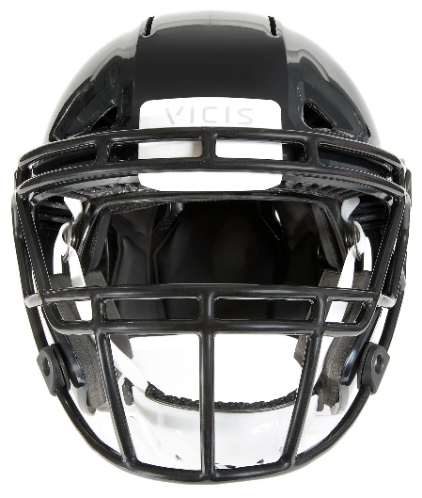
This Football Helmet Crumples—and That’s Good

Seattle startup Vicis tries to crack a tough market.
By Bryan Gruley and Peter Robison | January 11, 2016
Photograph by Caroline Tompkins/Bloomberg
Dave Marver presents two black football helmets that look pretty much alike. One is made by Riddell, the nation’s best-selling helmet manufacturer. The other is a prototype made by Vicis, the startup company for which Marver is chief executive.
He slams the crown of the Riddell model onto the concrete floor, producing the familiar violent crack of a strong safety blindsiding a wide receiver. Then Marver bangs his own company’s helmet down. The sound it makes is a flat, squishy thump—not something likely to thrill the average National Football League fan.
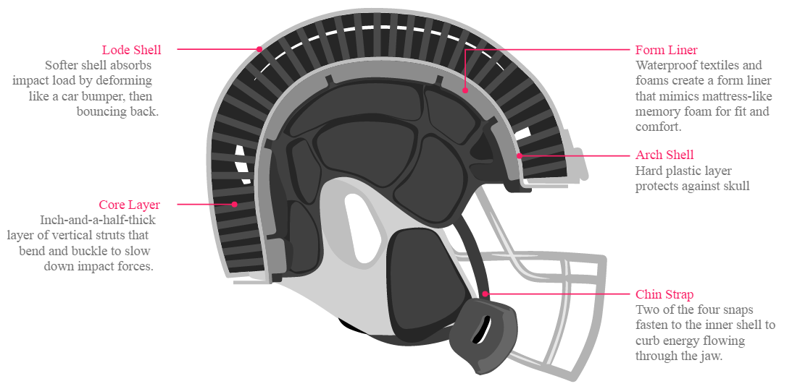
To treat football’s concussion epidemic, Vicis (VYE-sis) has redesigned the traditional football helmet. Instead of a rigid outer shell, the company’s new helmet, called Zero1, has a soft, deformable outer skin with a harder plastic core inside. Like a car’s bumper, the softer exterior gives a little when struck, slowing the impact before it reaches a tailback’s brain.
Additional layers further dampen impacts and cradle the player’s head in mattress-like memory foam. Two of the four chin-strap snaps fasten to the inner shell rather than the outer one, which Vicis’s engineers think will curb energy flowing through the jaw.
Dave Marver, Sam Browd, and Per Reinhall formed the company Vicis, a Latin word meaning change. They came up with a tectonic-plate concept that morphed into an “inside-out” helmet with a softer outer shell. The idea is similar to the way car bumpers are designed using crushable materials and structures that are better at protecting car occupants because they absorb energy as they collapse.
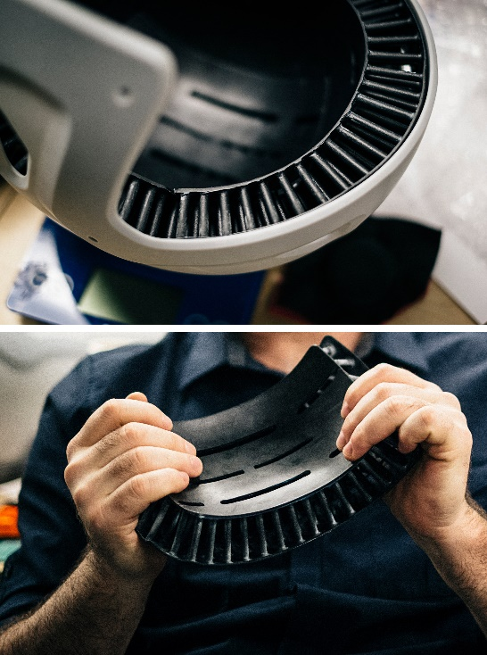
By slowing the impact—even by mere milliseconds—the crumpling eases the acceleration factor in Newton’s Second Law of Motion (force = mass x acceleration). Vicis chose a stiffer plastic for an inner core that guards against skull fractures.
The new helmet design also contains a black, 1.5-inch-thick layer of hundreds of tightly spaced struts fitted within the contours of the Zero1’s inner and outer cores. Like miniature shock absorbers, the struts buckle and flex on impact, sucking up energy before it reaches a player’s brain. The design was inspired by principles articulated by Swiss physicist Leonhard Euler in the 1700s that are now a foundation of structural engineering.
Close-up of inner layer with buckling struts.
Source: Vicis
“It was tricky because players don’t want to play with a marshmallow on their heads,” Marver says. “That’s why we were stoked to find an outer shell material that felt traditional—hard, shiny, paintable—but deformed locally upon impact.” All he’ll say about the material is that it’s a polymer plastic used in the auto industry. You can make a shallow dent in it with a thumb; it bounces back when you release.
Using finite element modeling, a method of digitally simulating a product’s real-world performance, Vicis engineers kept varying the number, position, and spacing of the buckling struts. They fitted multiple versions inside prototype helmets and tested them against Riddell and Schutt models in a UW lab. They dropped helmets from varying heights onto a hard rubber pad, mimicking the method used to certify NFL helmets, and slammed them from various angles with a weighted pendulum. A 3D print shop on the floor below finally complained about the constant thudding.
Vicis also hopes to reduce head trauma by offering a better fit. Traditional helmet sizes are small, medium, large, and extra-large. Some models contain padding that can be inflated with air to fine-tune fit. Last spring, Vicis measured the lengths and breadths of the craniums of 150 Seahawk and University of Washington players. Vicis used the data to create a dozen different sizes and shapes to accommodate varying head shapes.
Although safer than any other helmet designed so far, Vicis won’t be competing on price. They expect the helmet to go for around $1500, four to five times as much as other helmets.

